DATABASE TECHNOLOGIES-ASSIGNMENT 5
- Display all the first names in lower case and the last names in upper case as the single column separated with ' - '. Provide the meaningful name to the column.
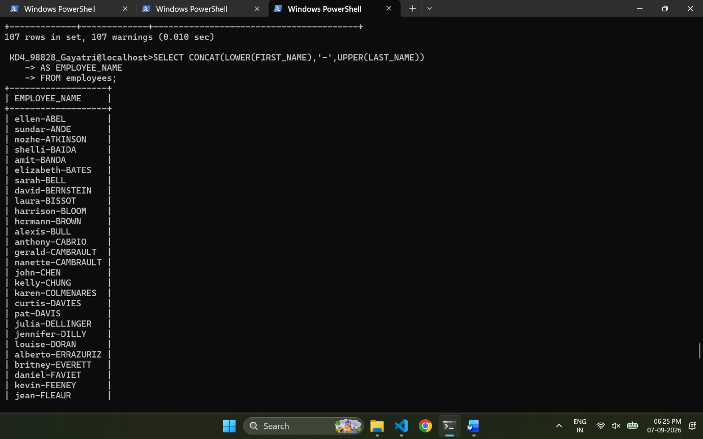
- Display the first word of the job title. (Hint : Use substring_index).
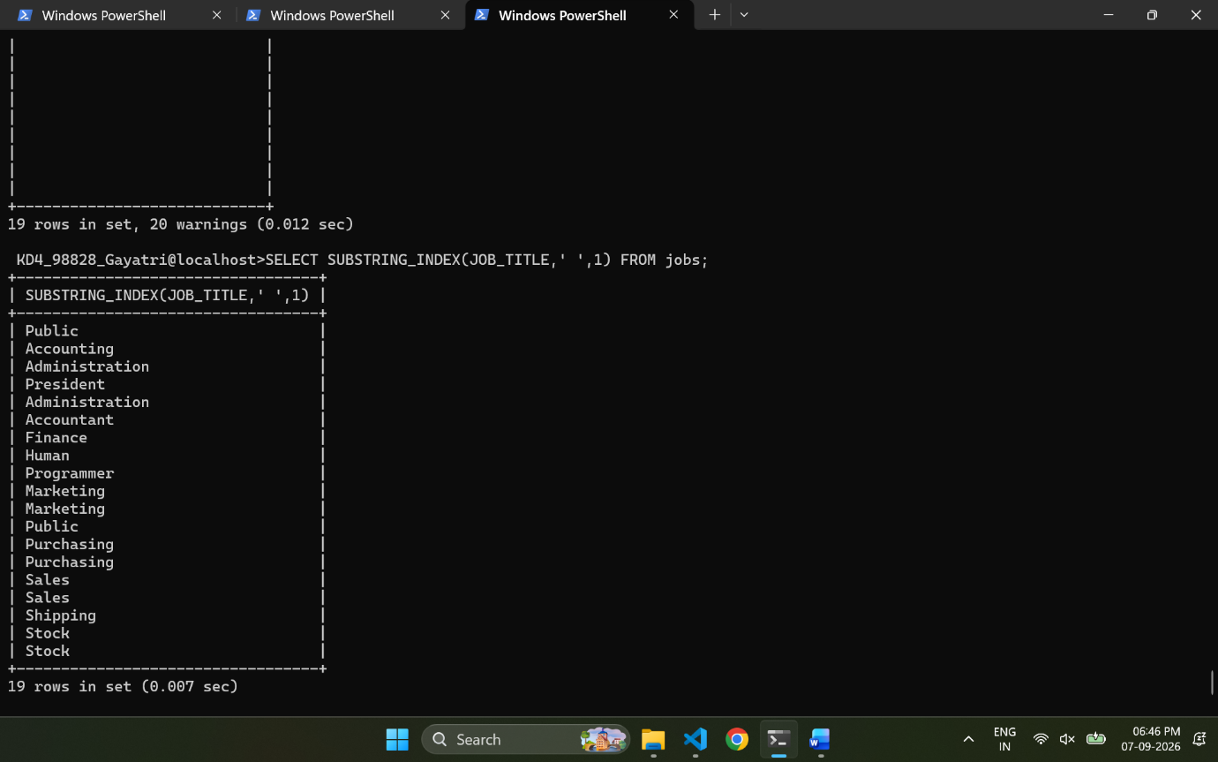
- Display the First name, last name and length of first name for the employees whose last name contains character ‘b’ anywhere after 3rd position.
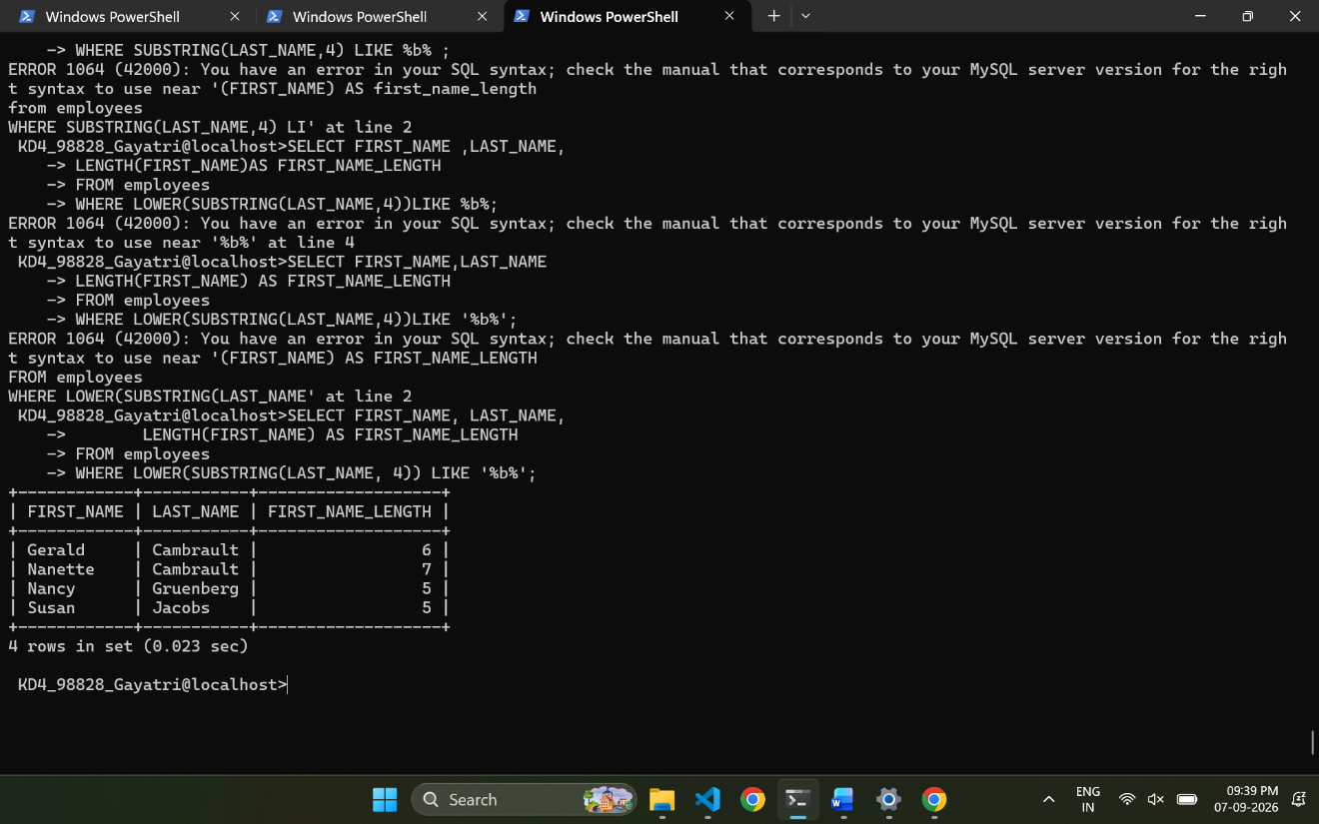
- Display the employee id, first name and last name of the employees whose first or last name includes a space in between.
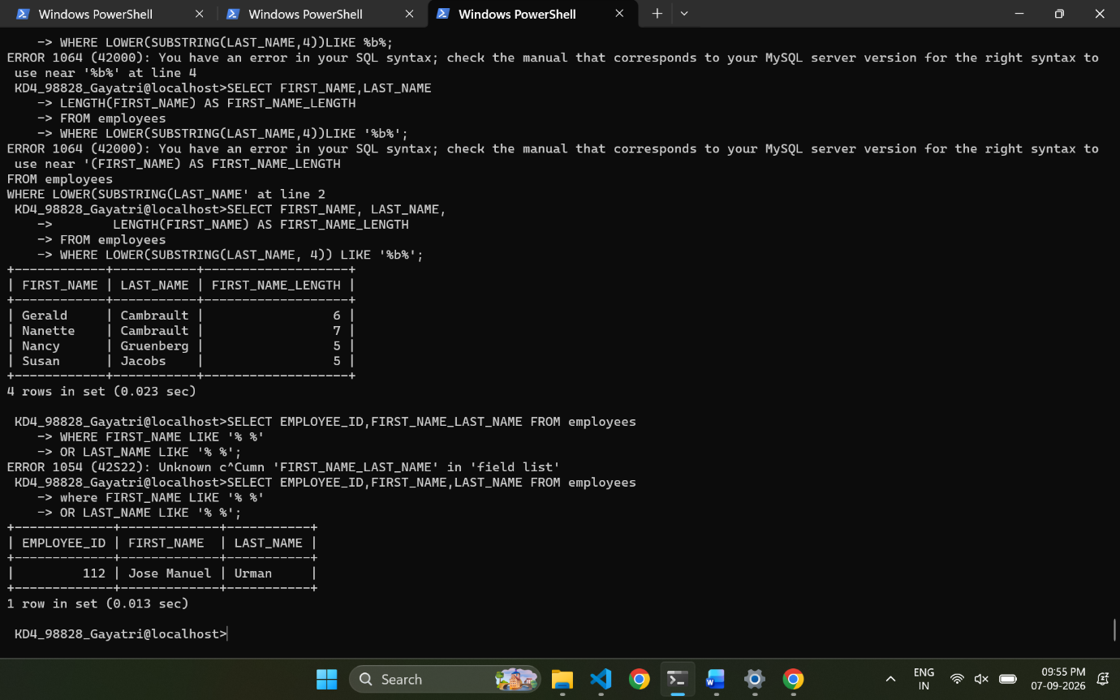
- Display first name, salary, and round the salary to thousands.
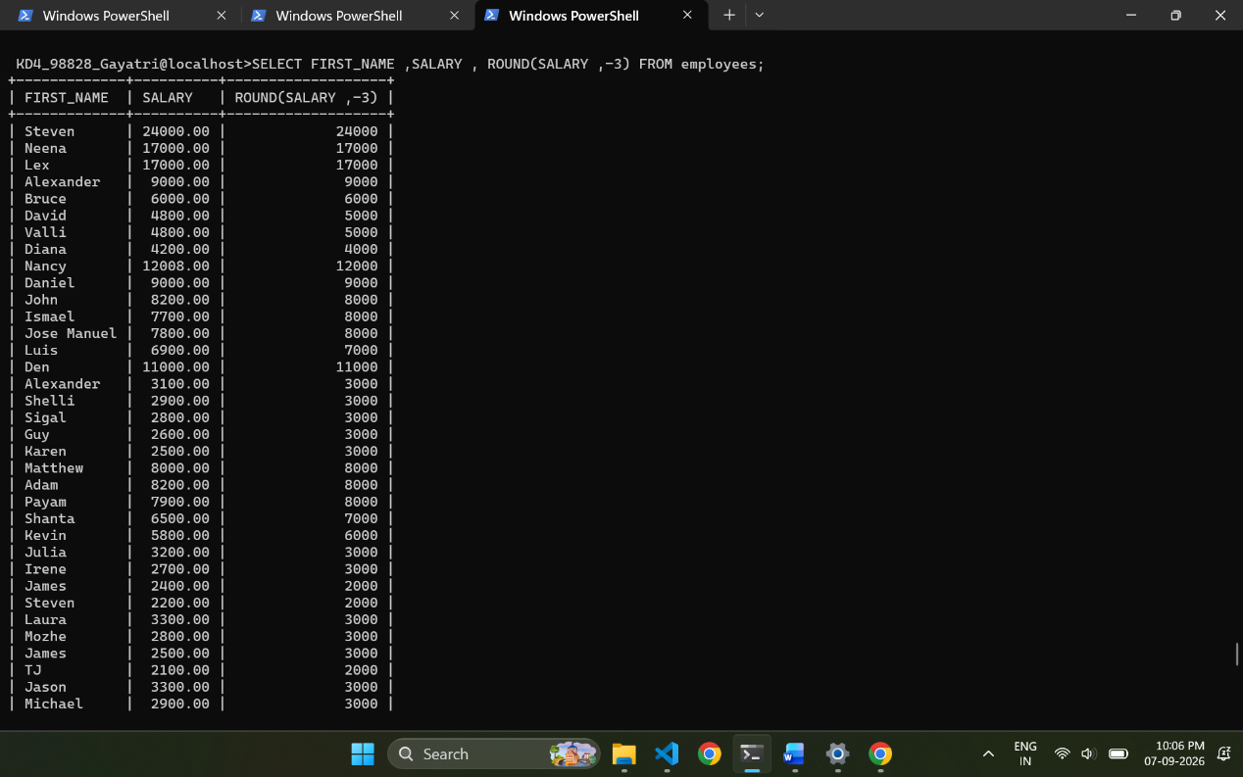
- Display employee ID and the date on which he ended his previous job in the format as mentioned. (Format: Thursday, October 27th 2011)
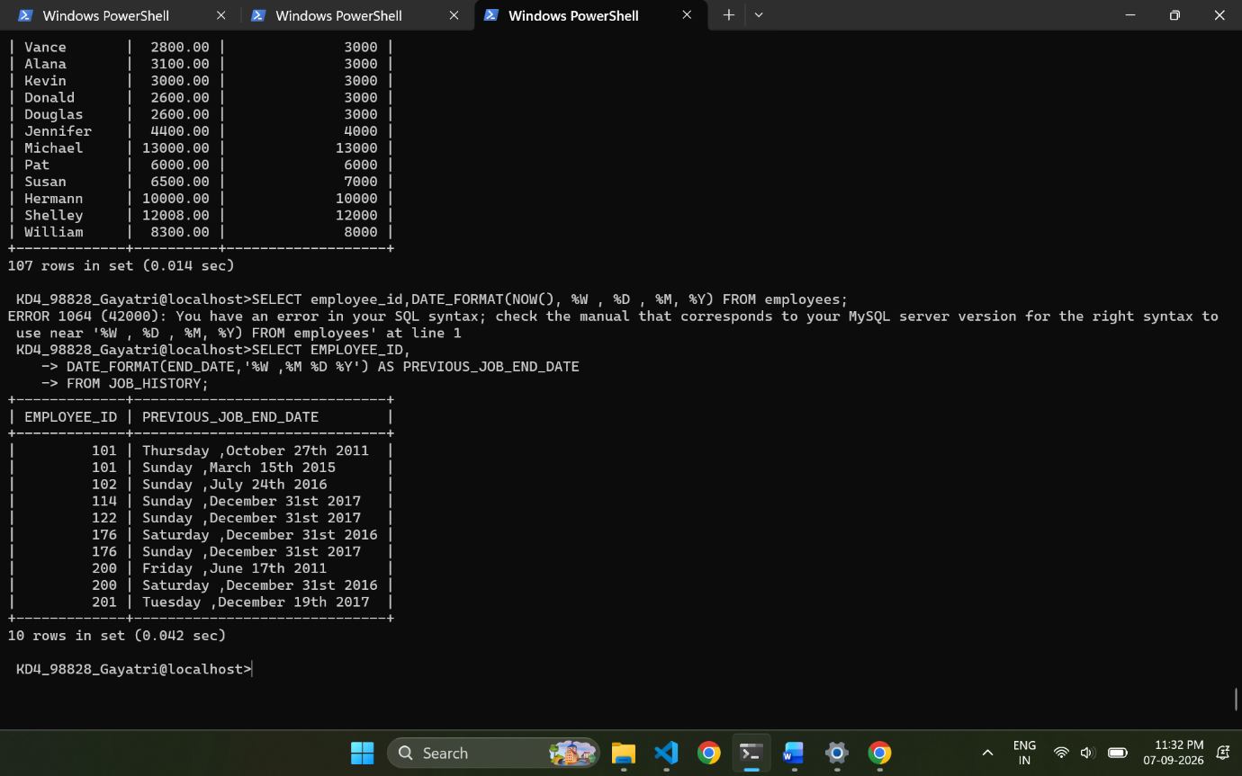
- Display first name and date of first salary of the employees. (Consider 1 st day of month as salary day. HINT: LAST_DAY).
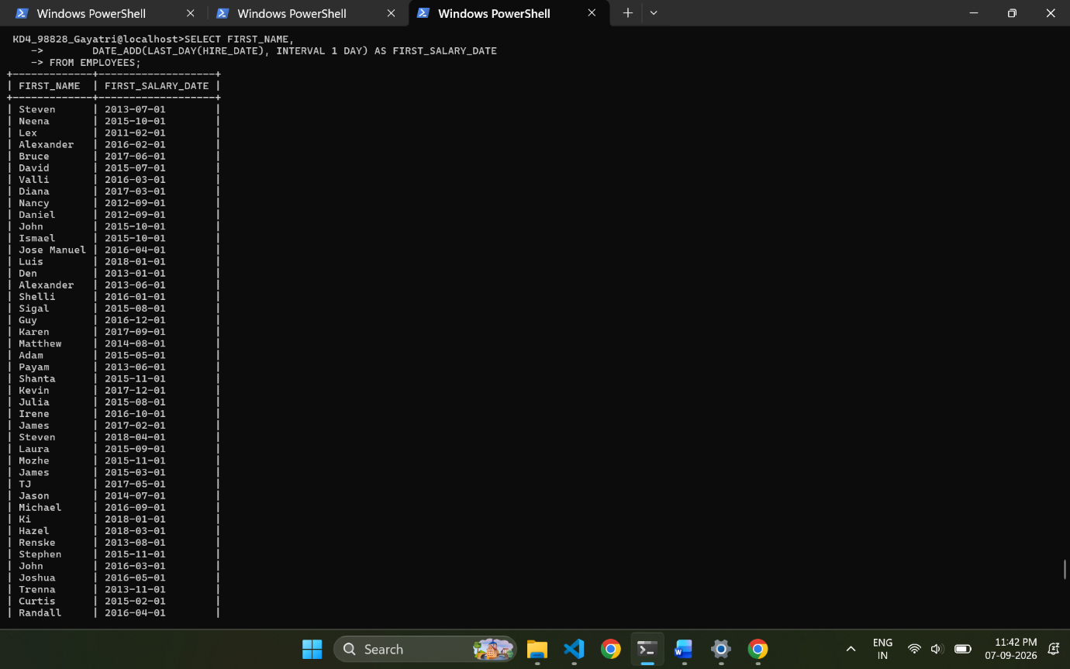
- Display first name and experience of the employees in the format of number of years, months and days completed.
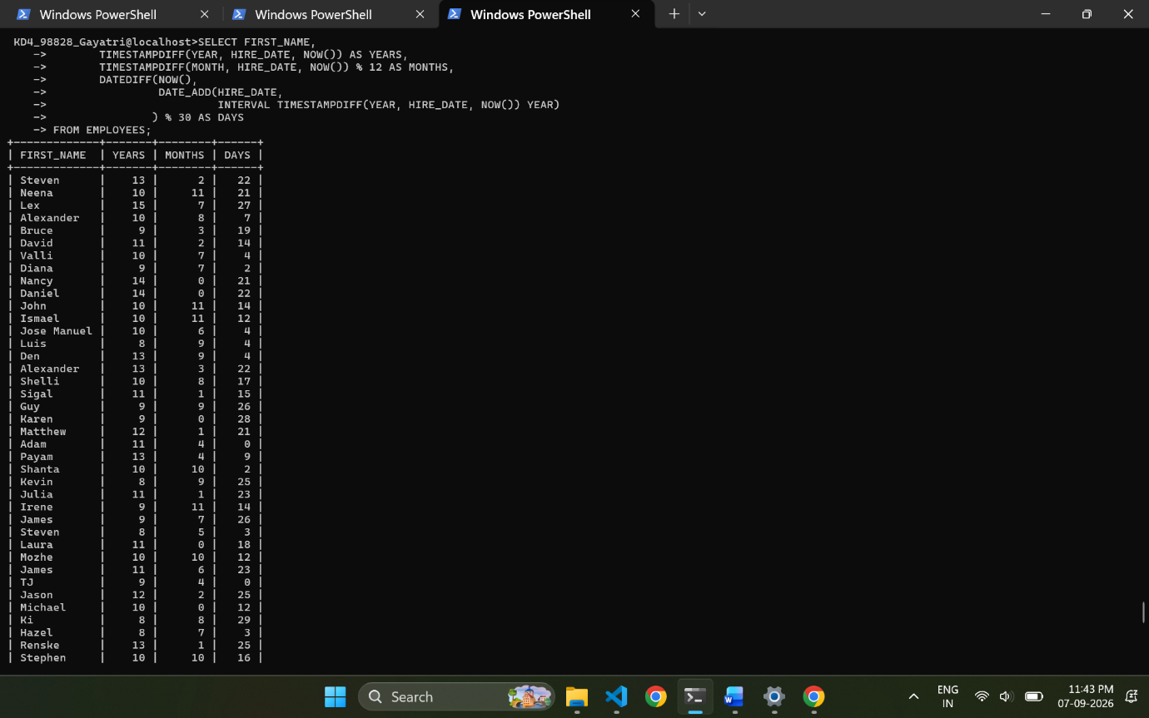
- Display the employee id, first name and joining date of the employees who joined in the month of august of any year.
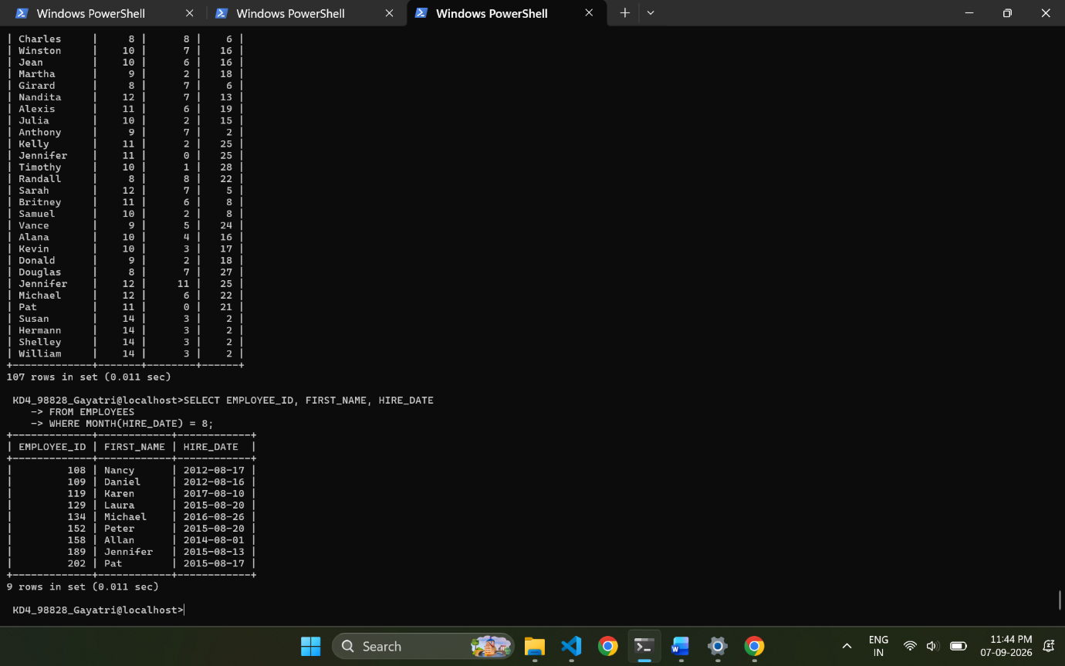
- Display the details of employees who joined before the year 2015.
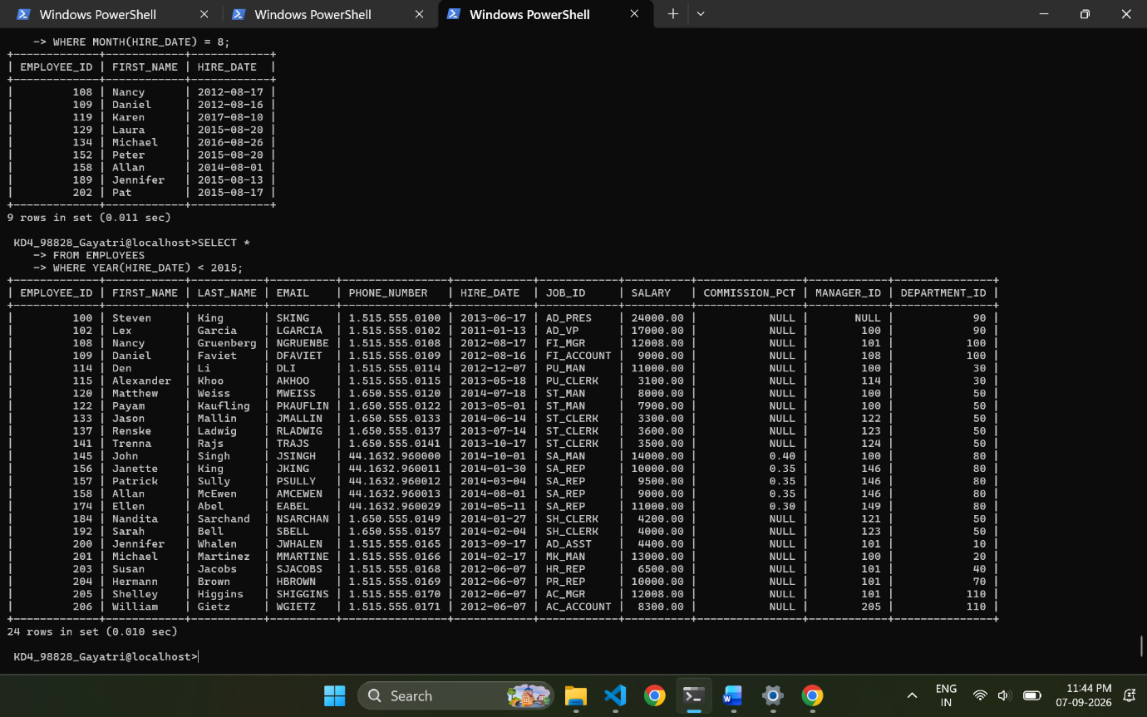
- Display the number of days between system date and 1st January 2011.
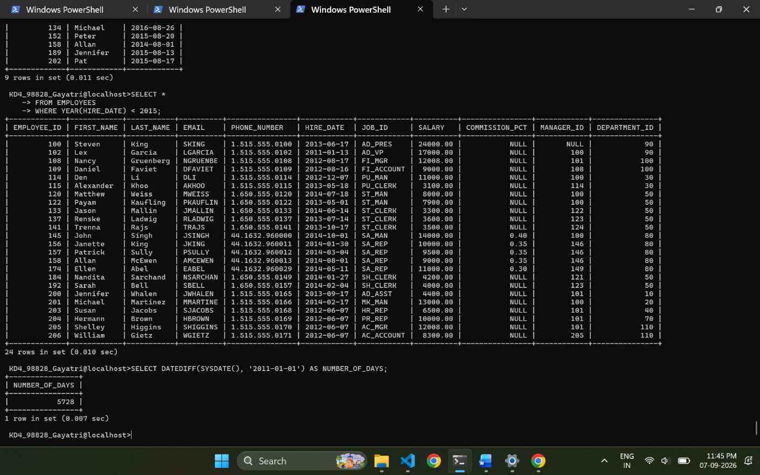
- Display number of employees joined after 15th of any month.
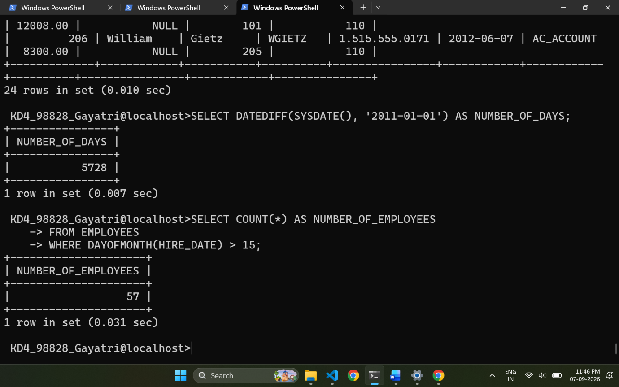
- Display third highest salary of employees.
